Assignment-1

Name: MOHIT GUPTA

Sr. No. 15755

M.Tech. (Course)

CSA, IISc

***Problem1:***

***Bonus Question:***

Provided Constraints on each item in Inventory as a Maximum value represented as Vector V, also we know that M matrix stores the percentages of values to be used, taken from items from Inventory out, let X be the vector that represents the Quantity of each item taken.

M*X is the quantity of Potion of “Lin-Algebrica” that can be prepared by students, we are given a target vector B, containing quantity to be prepared.

But, in case of constraints placed by Inventory, it is not possible to achieve B perfectly. Now, to find out what maximum amount can be prepared can be formulated as follow,

M*X is the amount of Potion prepared by students which need to be Maximized. In this part, M is already given to us, now X can maximize the quantity M*X, but due to constraints we know that X can be at max equal to V vector.

So, for producing maximum amount of “Lin-Algebrica”, it is the case that V itself should be considered as the solution vector X, taken quantity.

Maximum_Quantity = M*V

***Problem 2:***

***Second Part:***

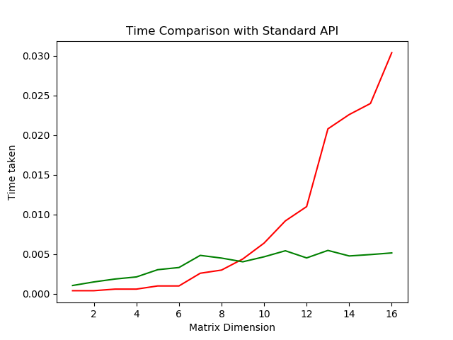

Figure The Red curve represents time taken by our algorithm vs the green curve showing the time time taken by Standar API Numpy.

The above graph compares the time taken by my algorithm & standard python API (Numpy) on various sizes to find inverses.

Numpy turns out to be faster for finding Inverses of matrices with large sizes.

1. We can use vectorization via numpy matrix or any similar type of library which perform vectorization to compute matrix multiplication or inverse.
2. Parallelization among CPUs via OpenMP or CUDA.

***Third Part:***

So instead of row operation we have to use column operations.

We can simply imply that column operation on A == row operation on AT.

Now, let's say if A-1 exists for A. Then we have to prove that (AT)-1 exists for AT.

Since we know that transpose and inverse are inter-changeable as **(AT)-1==(A-1)T**.

Now if A-1 exists so (A-1)T will also exist and thus (AT)-1 will also exist.

This also proves that if we perform only column operations then too we can get inverse of A.

***Problem Two:***

***Bonus:***

**Method 1**:- The way to solve is to use Multiply&ADD and Multiply only.

With these two operations we can perform all the three operartions.

Consider two rows r1 and r2 , along with two operations Multiply&ADD and Multiply we need to prove that we can perform the switch instruction.

perform these operations on the chosen rows:

r1=r1+r2;

r2=r1-r2;

r1=r1-r2;

After performing these operations we can clearly visualize that the values in the rows gets interchanged, hence switch operation is performed.

**Method** **2**:- Other way is to Take Switch and Multiply&ADD (Applicable in the above problem only and will obviously violate the conditions of elementary row operation that Multiply&ADD operation has two different rows but here if we allow to perform the above operation on same row then we can achieve the target).

Where we convert the pivot element to 1 by using Multiply, we can simply do that by Multiply&ADD.

We want to convert x into 1:-

1=x+ a.x

a= (1-x)/x